Gantt chart and updated road map:

Gantt chart:

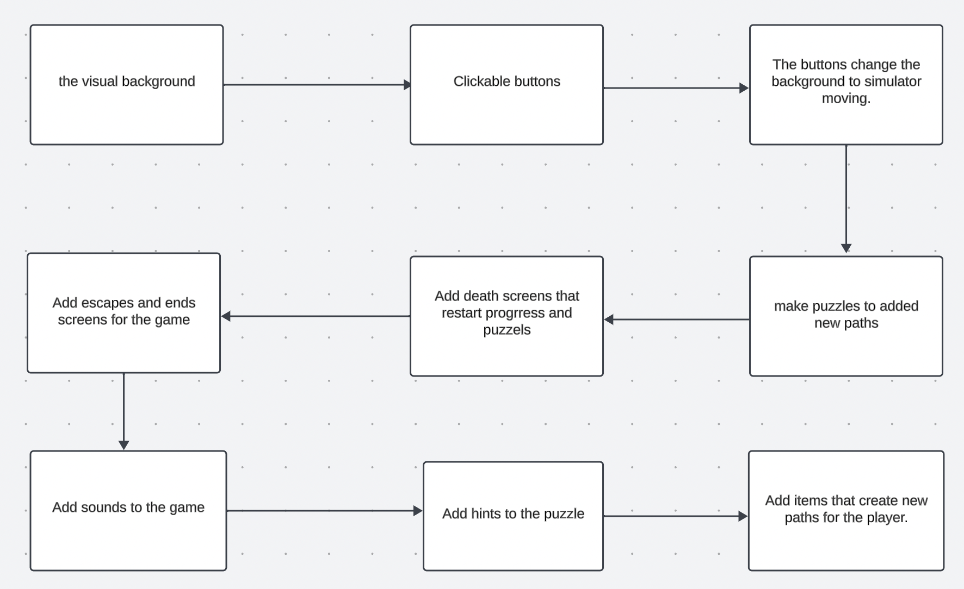Updated road map:



Highlighted features are completed.